

**Selecting Behavioral**

**Health Prevention**

**Programs**



**A Guide for Kentucky Schools**

**Grades K**

**-**

**12**

July

2020

Updated June 2021

Updated June 2023



**Table of Contents**

**Introduction .................................................................................................................**...1

**Five Steps to Selecting Prevention Programs for *Your* School ..................................** 2

Step 1. Determining Need .................................................................................................... 2

Step 2. Getting Key Players on Board ...................................................................................4

Step 3. Determining Program Fit ................................................................................... 4

Step 4. Working out the Details ............................................................................................4

Step 5. Tracking Progress ........................................................................................................6

**Additional Resources and Support ..............................................................................**8

**Appendix** ........................................................................................................................9

Appendix A: Program Key Information – Example Worksheet ..........................................9

Appendix B: Program Key Information-Sample Worksheet ...............................................12

Appendix C: Example Planning Logic Model .................................................................... 13

Appendix D: Sample Planning Logic Model .......................................................................14

Appendix E: Sample Evaluation Logic Model .....................................................................15

Appendix F: Program Fidelity Checklist ................................................................................16

Appendix G: Beyond Programs ............................................................................................17

Appendix H: State Approaches……………….…………………………………………………. 20

Appendix I: Regional Prevention Centers……………………………………………….......... 22

# Introduction

This toolkit is a guide Kentucky schools can utilize as they select programs and practices to reduce substance use/misuse, mental health, and violence issues. Across the nation, youth are struggling with substance use and misuse, mental health, and violence issues. These issues impact individual students and deeply affect a school’s ability to provide the most effective education. The good news is we have more information than ever about the powerful role

schools can play in reducing these problems. This document is a guide for Kentucky schools as they update substance use prevention efforts. It focuses on evidence-based and evidence-informed programs.

The following pages include process steps, information, and tools to select the best programs for individual schools. This guide can help research and answer questions that will assist in the decision-making process. This document does not provide a prescriptive list of “recommended programs” for the following reasons:

* Selection of programs should fit an individual school’s needs and resources. A program that works well in one school may not be a good fit for another.
* Selecting programs is just one part of the process. Being able to implement the program with fidelity (i.e., as it was designed to be implemented, from content and structure to instructional methods), and tracking and evaluating progress are equally important.
* The prevention field is dynamic and evolving. To have the greatest impact, prevention programs and systems need to be responsive to new research. New programs are continually being developed and evaluated and schools should make certain they are working with the most up-to-date information as they undergo program selection, implementation,and evaluation.

A Developmental Approach

“Preventive interventions begun early in life may have comparatively stronger effects because of the malleability of several developmentally central risk factors, such as family relationships, peer interactions, cognitive development, and emotional regulation.”

(Institute of Medicine, 2009)

1

**Five Steps to Selecting Prevention Programs for Your School**

The following steps are adapted from Substance Abuse and Mental Health Services Administration (SAMHSA) Strategic Prevention Framework (SPF): Each step includes a list of questions that can help to target your school’s prevention efforts.

***Step 1: Determining need.***

Resources are limited. It is important to conduct an assessment to help focus efforts. This step includes collecting and examining data, assessing areas of need, weighing available resources, and selecting priorities.

**a. What risky health behaviors occur with the greatest frequency, are on the rise, and/or take the greatest toll in your classrooms?**

* What data do you have available on health risk behaviors such as substance use, mental health, and violence in your school community? For example, you might use data from the Kentucky Incentives for Prevention (KIP) Survey or your school’s own administrative records.
* Which grades or student groups are most affected by these behaviors?
* Which health risk behaviors are of greatest concern to your school community? Do you have interview or focus group data from school staff, community members, parents, and students to show their concerns?

**b. What factors are known to contribute to these health risk behaviors?**

* Normative beliefs: Do youth believe adults and/or peers think it is okay or “cool” for them to use substances? Do peer and adult norms support non-use?
* Availability: How easy or difficult is it for youth to get substances?
* Enforcement: Do youth believe they will get caught and face consequences from school officials, and/or law enforcement?
* Parental monitoring: Do youth believe they will be caught by their parents and face consequences as a result?
* Social and emotional competencies: Research shows problems such as substance use generally do not show up until adolescence, however, these problems are strongly predicted by whether certain social and behavioral skills are nurtured during childhood (see, “A Developmental Approach” on page 1). This means we cannot ignore the essential role of preschools and elementary schools. For more information, see Appendix G: Beyond Programs: Examples of Proven, Low-to-No-Cost Prevention Strategies.

|  |
| --- |
| **School-based Prevention… What doesn’t work?**  The following approaches to prevention have consistently been found to be ineffective in reducing alcohol use and in some cases, other high-risk behaviors:   * Relying on provision of information **alone**, fear tactics, or messages about not drinking until one is “old enough.” * Focusing solely on increased self-esteem. * Focusing solely on strategies to resist peer pressure. * Identifying youth who have problems with alcohol use and other high-risk behaviors and putting them together in groups. (Institute of Medicine, 2004)   Examples: Zero-Tolerance policies, Scared Straight programs (Ghost Outs, mock crashes), one-time events such as speakers in recovery or family members of those in recovery. |

**c. What prevention programs and practices are you currently implementing to address these health risk behaviors?**

* What are the strengths of your current programming and what are the weaknesses?
* What have been the teachers’ reactions to the current programming?
* Have there been any obstacles to program implementation? Are programs implemented as intended by their developers or do teachers make significant modifications?
* Are any of the programs using non-recommended strategies (see side bar, “What doesn’t work”)?
* Are any of the programs listed on a federal registry of evidence-based programs? If so, what kind of ratings did they receive? (see Step 3, Selecting Priorities and Programs, for a list of searchable online registries)
* Is there evaluation data to show if current programs are achieving outcomes in reducing the problems they are meant to prevent?

**d. What resources are available for implementing prevention curricula in your school?**

* Is there funding or room in the current budget to support new prevention programming?
* Are there limitations or conditions for the ways the funding can be used?
* Which staff are available? Which staff are interested? Would staff require additional training?
* Can time be carved out during the school day for new programming? When would that happen?

***Step 2: Getting key players on board.***

A prevention program will more likely be implemented and sustained if there is support from teachers, administrators, students, parents, and community. Make sure key players are involved from the beginning in setting priorities and selecting programs.

1. **Who needs to be on board to create changes in your school’s prevention programs and how they are implemented?**
2. **How can you get these key individuals involved throughout the process of program selection, implementation, and evaluation?**

***Step 3: Determining program fit.***

Before selecting a new program, consider criteria including evidence of effectiveness, feasibility of implementation, and cost. Answer the following questions based on your findings to Step 2:

**a. What evidence-based programs address the needs identified in Step 2?**

The following websites provide a searchable database of exemplary, effective, and promising programs:

* Blueprint Programs-Positive Youth Development <https://www.blueprintsprograms.org/programs/>
* What Works Clearinghouse <https://ies.ed.gov/ncee/wwc/>
* Office of Juvenile Justice and Delinquency Prevention <https://www.ojjdp.gov/>
* Pay attention to the ratings received by each program on these websites. Some programs listed on these registries may have low ratings that indicate that no positive changes have been found or the programs may even have been found to cause harm. Other programs may have been evaluated with less rigorous research methods. Each registry’s ratings will provide some context and description tohelp determine whether a specific program has good evidence for supporting positive change and is a good fit for your community.
* Appendix H provides a list of approaches supported by Kentucky’s state and federal substance use prevention funding. Contact your local Regional Prevention Center for more information on these programs.

**Of the programs you identified under question 3-a. above, which are feasible to implement? Consider available resources and capacity—including staffing, instructional time, and funding.**

* Will you be able to implement the program as designed to be most effective?
* What additional support is available in your local community? There may be prevention groups that could be helpful partners and advocates in seeking additional funding and/or resources to bring evidence-based programs to your school. Access technical assistance from your local Regional Prevention Center. Contact information is included in Appendix I.

**b. If your school can only implement one or two programs, which would you choose?**

**Which ones could go on a “wish list” to be pursued later?**

Some things to consider:

* Choose quality over quantity. It is better to do one program well with impact, than to do five poorly, with little effect.
* In narrowing down options, it can be helpful to consider a variety of factors that include both importance (level of need) and feasibility—such as buy-in from key stakeholders (instructors, administrators, parents, funders), available resources, capacity to implement the program with fidelity, and estimated ratio of cost/benefits of adopting the program.
* Ensure the program aligns with KRS 158.441 (The School Safety and Resiliency Act) (2019) and KRS 158.6453 (2018) enacted by the Kentucky General Assembly. These bills require suicide prevention awareness information and annual, age-appropriate, instruction in drug awareness for all students in Kentucky schools beginning in school year 19-20.

With limited resources, the natural tendency is often to focus prevention efforts on a few individuals who have been designated as having the highest need. While these *selective* and *indicated* approaches serve an important role, they can sometimes result in “rationing” of services to a selective few. *Universal* approaches are implemented with the general population regardless of risk level and tend to be successful in achieving reductions in risk behaviors *even among higher-risk participants*. Schools should develop a prevention plan that is as comprehensive as possible. Universal, selective, and indicated approaches are all important

components of a comprehensive prevention plan.

***Step 4: Working out the details.***

Once you have identified a program that seems to fit your school’s needs and resources, you are ready to start planning the nuts-and-bolts of making the program a reality.

* 1. **What are the essential components of the program and how will you fulfill them?**

For each selected program, create an outline or chart (Appendices B & C) of key information identified on the developer’s website or materials. A Program Key Information sample worksheet is included in Appendix A.

It may be helpful to create a chart or logic model (Appendices B & C) that visually links program inputs and outputs. Some programs come with their own planning tools, available from program developers.

* 1. **What additional resources are needed to implement the program effectively?**

What funding sources are available to support evidence-based prevention curricula in your school?

Regional Prevention Centers (RPCs) often have access to free or reduced-cost educational materials for your school. A complete list of RPCs by county is included in this packet (Appendix I).

* 1. **What preparation steps can be taken to increase the school’s readiness and capacity to implement the program successfully?**

Site readiness and capacity are key factors in enhancing fidelity of program implementation3. Elements include:

* A well-connected and respected local champion
* Strong administrative support
* Formal organizational commitments and staffing

stability

* Up-front commitment of necessary resources
* Program credibility within the community
* Some potential for program routinization

Before moving forward, it is recommended that a school meet at least 4 of the 6 elements for readiness and capacity.

***Step 5: Tracking progress.***

It is important to set up evaluation systems *before* a program begins. This includes deciding on the intended *outcomes* and how they will be measured. It also includes outlining the intended program activities or *processes* and how they will be documented.

For each selected program, it can be helpful to create a chart or logic model that allows the reader to visually link this information. The chart can serve as a valuable tool for instructors, administrators, and funders alike. For a sample fill-in-the-blank Evaluation Logic Model see Appendices B & C.

**a. *Process* evaluation:**

* **What systems will you put into place to measure whether the selected programs are implemented correctly?**

Evidence-based programs are designed to be implemented in a certain way to be effective. For example, considerations may include number and length of sessions, content of sessions, and use of program materials. A sample worksheet to track program fidelity is included in Appendix F. Many programs come with their own fidelity checklists and tools, available from program developers.

* **What processes will you put into place for program instructors to document and share what is working for them, what is not, and ideas to improve success?**

There are several ways to track this valuable information—including meeting notes and written reports.

**b. *Outcome* evaluation:**

• **What data will you use to measure the selected programs’ success in achieving the priorities identified in Step 2?**

For example, if a program was chosen to reduce overall youth alcohol use, you might compare underage drinking rates before and after the program is implemented, using data from the Kentucky Incentives for Prevention (KIP) Survey. Please note that most programs do not impact substance use rates specifically, but rather impact risk and protective factors that in turn result in reductions in substance use (i.e. a program may address the perception that substance use is risky. Research shows that when youth perceive increased risk in a behavior, they are less likely to participate in that behavior).

Some programs include evaluation tools such as tests or surveys to administer to students before and after the program. Be sure to include any costs in using these tools in your program budget.

**c. What systems will you put into place to review and utilize the information collected?**

It is essential to review and analyze evaluation data at regular intervals, to determine whether the program is achieving its intended outputs (process measures) and outcomes and decide how this information will be used. This includes sharing information with program funders, instructors, administrators, parents, students, and the community—and engaging them in the process.

# Additional Resources and Support

The Department of Substance Use Disorder (DSUD)Prevention and Promotion Branch supports the implementation of evidence-based substance use prevention strategies and programs by non-profit agencies and schools across Kentucky. The Branch works closely with the Regional Prevention Centers (RPCs) across the Commonwealth to provide technical assistance, information, and training to community partners and schools. The RPCs also work with community stakeholders to support the implementation of substance use programming and resources. Resources include:

**Kentucky Incentives for Prevention (KIP) Survey:**

<https://www.kipsurvey.com/>

The KIP survey is Kentucky’s largest source of data related to student use of alcohol, tobacco, and other drugs (ATOD), as well as factors related to potential substance use. In October 2021, more than 93,000 students representing 127 school districts completed the survey, and the information gathered provides an invaluable substance use prevention tool for communities. Districts utilize their KIP results extensively for grant-writing purposes, prevention activities, and various other needs related to program planning.

The KIP survey provides information about student self-reported use of substances (e.g., within the last 30 days, last year), student perceptions about substance use (e.g., level of risk, peer and parent disapproval), and perceived accessibility of substances in the community. The survey also includes questions related to mental health, bullying, dating violence, school safety, and suicidal behaviors. Once the survey data are gathered and analyzed, each participating school district receives a report outlining district-specific results, and depicting comparisons to the region, state, and (when available) the rest of country.

On this site you can find recent publications, information related to technical aspects of the KIP survey, links to relevant resources, and contact information to learn more.

## Appendix A: Program Key Information – Example Worksheet

Below is a sample worksheet based on information from a program website. For accurate and up-to-date information, please confirm with program developers.

## Appendix A: Program Key

The information below is an example of information pulled from a program developer’s website and does indicate that CHFS endorses this program for implementation in your school.

|  |  |
| --- | --- |
| Program Name | Too Good for Drugs |
| Developer Contact Info/Website | <https://toogoodprograms.org/> |
| Training requirements/ options | The fidelity model for Too Good for Drugs includes completion of a Curriculum Training session as part of its built-in quality assurance mechanism.  Modes of Training:  Customized on-site training to facilitate the agency climate, strategies for connecting with families and communities, and curriculum training  Group curriculum training provided at regional settings (Open Enrollment  Curriculum Training Sessions)  Technical assistance and implementation support via email, teleconference, or videoconference. |
| Training Cost | On-site Training: See website for current costs.    Open Enrollment Curriculum Training: See website for current costs.  **\*\*Training and materials for this program may be available at low or no cost through the Regional Prevention Centers.** |
| Materials requirements/ options | Requirements: Program Kits – Grades K-HS (includes Teacher Manual, 30 student workbooks, visuals, and activities in lessons).  Program Consumables: Student Workbooks |
| Materials Cost | Program Kits: See Website for current costs |

|  |  |  |
| --- | --- | --- |
| Instructors | Too Good for Drugs is designed to be provided by professionals such as teachers, guidance counselors, social workers, resource officers, prevention specialist, etc. within a school system or community agency who are certified through the Too Good for Drugs program. | |
| Number and  duration of sessions | 10 lessons, one per week | |
| Timing and frequency of sessions | One, 30–50-minute class session per week, although alternative delivery of the sessions can occur. Talk to your local prevention specialist for guidance. | |
| Order of sessions | All lessons are delivered in sequential order | |
| Booster sessions? | Each of the 10 lessons at each grade level of the program includes a Home Workout, quick take-home lesson on the lesson topic, inviting family to support, practice, and reinforce what their child is learning in the program. | |
| Instructional  Methods | Youth participate in an interactive classroom setting designed to instruct, review, and reinforce the skills and social constructs built into the lessons. Each lesson builds upon the previous to stack the learning and continue to reinforce for retention and immediate application. | |
| Content of the  Sessions | Development and strengthening of personal and interpersonal skills in:   * Goal setting * Decision making * Effective communication * Prosocial bonding * Respect for self and others * Managing emotions * Normative expectancies     Additional skills and developmental topics build on the core social skill set to broaden the student’s sense of self-efficacy and confidence and are tailored to the intellectual, cognitive, and social development of the student.    Depending on the applicable developmental level, areas of focus include:   * Media literacy and media influence * Resisting peer pressure * Understanding peer influence * Understanding addiction * Complex social and dating relationships * Exploring risk taking and differentiating healthy and unhealthy risks | |
|  |  | The curriculum emphasizes the negative consequences of drug use and the benefits of a drug-free lifestyle, thereby working to build student resiliency to inappropriate and harmful drug use. ATOD topics include: |
|  | • | Prescription and OTC drugs |
|  | • | Stimulants |
|  | • | Depressants |
|  | • | Alcohol |
|  | • | Nicotine including tobacco and vaping |
|  | • | THC and marijuana |
| Use of materials | • | Program kits provide educators with the essentials they need to implement the Too Good programs. |
|  | • | Each program kit includes a teacher’s manual with fully scripted lessons, take home activities, lesson extenders, and evaluation instruments. Kits also include a starter pack of student workbooks, game materials, role play scripts, and other activity materials to get you started. |
| Setting | • | Community agencies, school (classroom), residential, group home, or congregate care |
|  | • | Too Good for Drugs program kit for the grade level(s) of the class or students and a student workbook for each student. |
|  | • | Delivery sites must have space for students to sit in a classroom-type setting that can accommodate individual, paired, and group work. Some grade levels of the program require use of a CD or DVD for a portion of the material delivery. A blackboard or marker board and access to a photocopier are necessary. |
| Intended classroom Audience | • | Children and adolescents ages 5-17 |
| Instructor/ participant ratio | • | N/A |

***Appendix B: Program Key Information – Sample Worksheet***

|  |  |
| --- | --- |
| **Program Name** |  |
| **Developer Contact Info/Website** |  |
| **Training**  **requirements/options** |  |
| **Training Cost** |  |
| **Materials**  **requirements/options** |  |
| **Materials Cost** |  |
| **Instructors** |  |
| **Number and**  **duration of sessions** |  |
| **Timing and frequency of sessions** |  |
| **Order of sessions** |  |
| **Booster sessions?** |  |
| **Instructional methods** |  |
| **Content of the sessions** |  |
| **Use of materials** |  |
| **Setting** |  |
| **Intended classroom audience** |  |
| **Instructor/ participant ratio** |  |

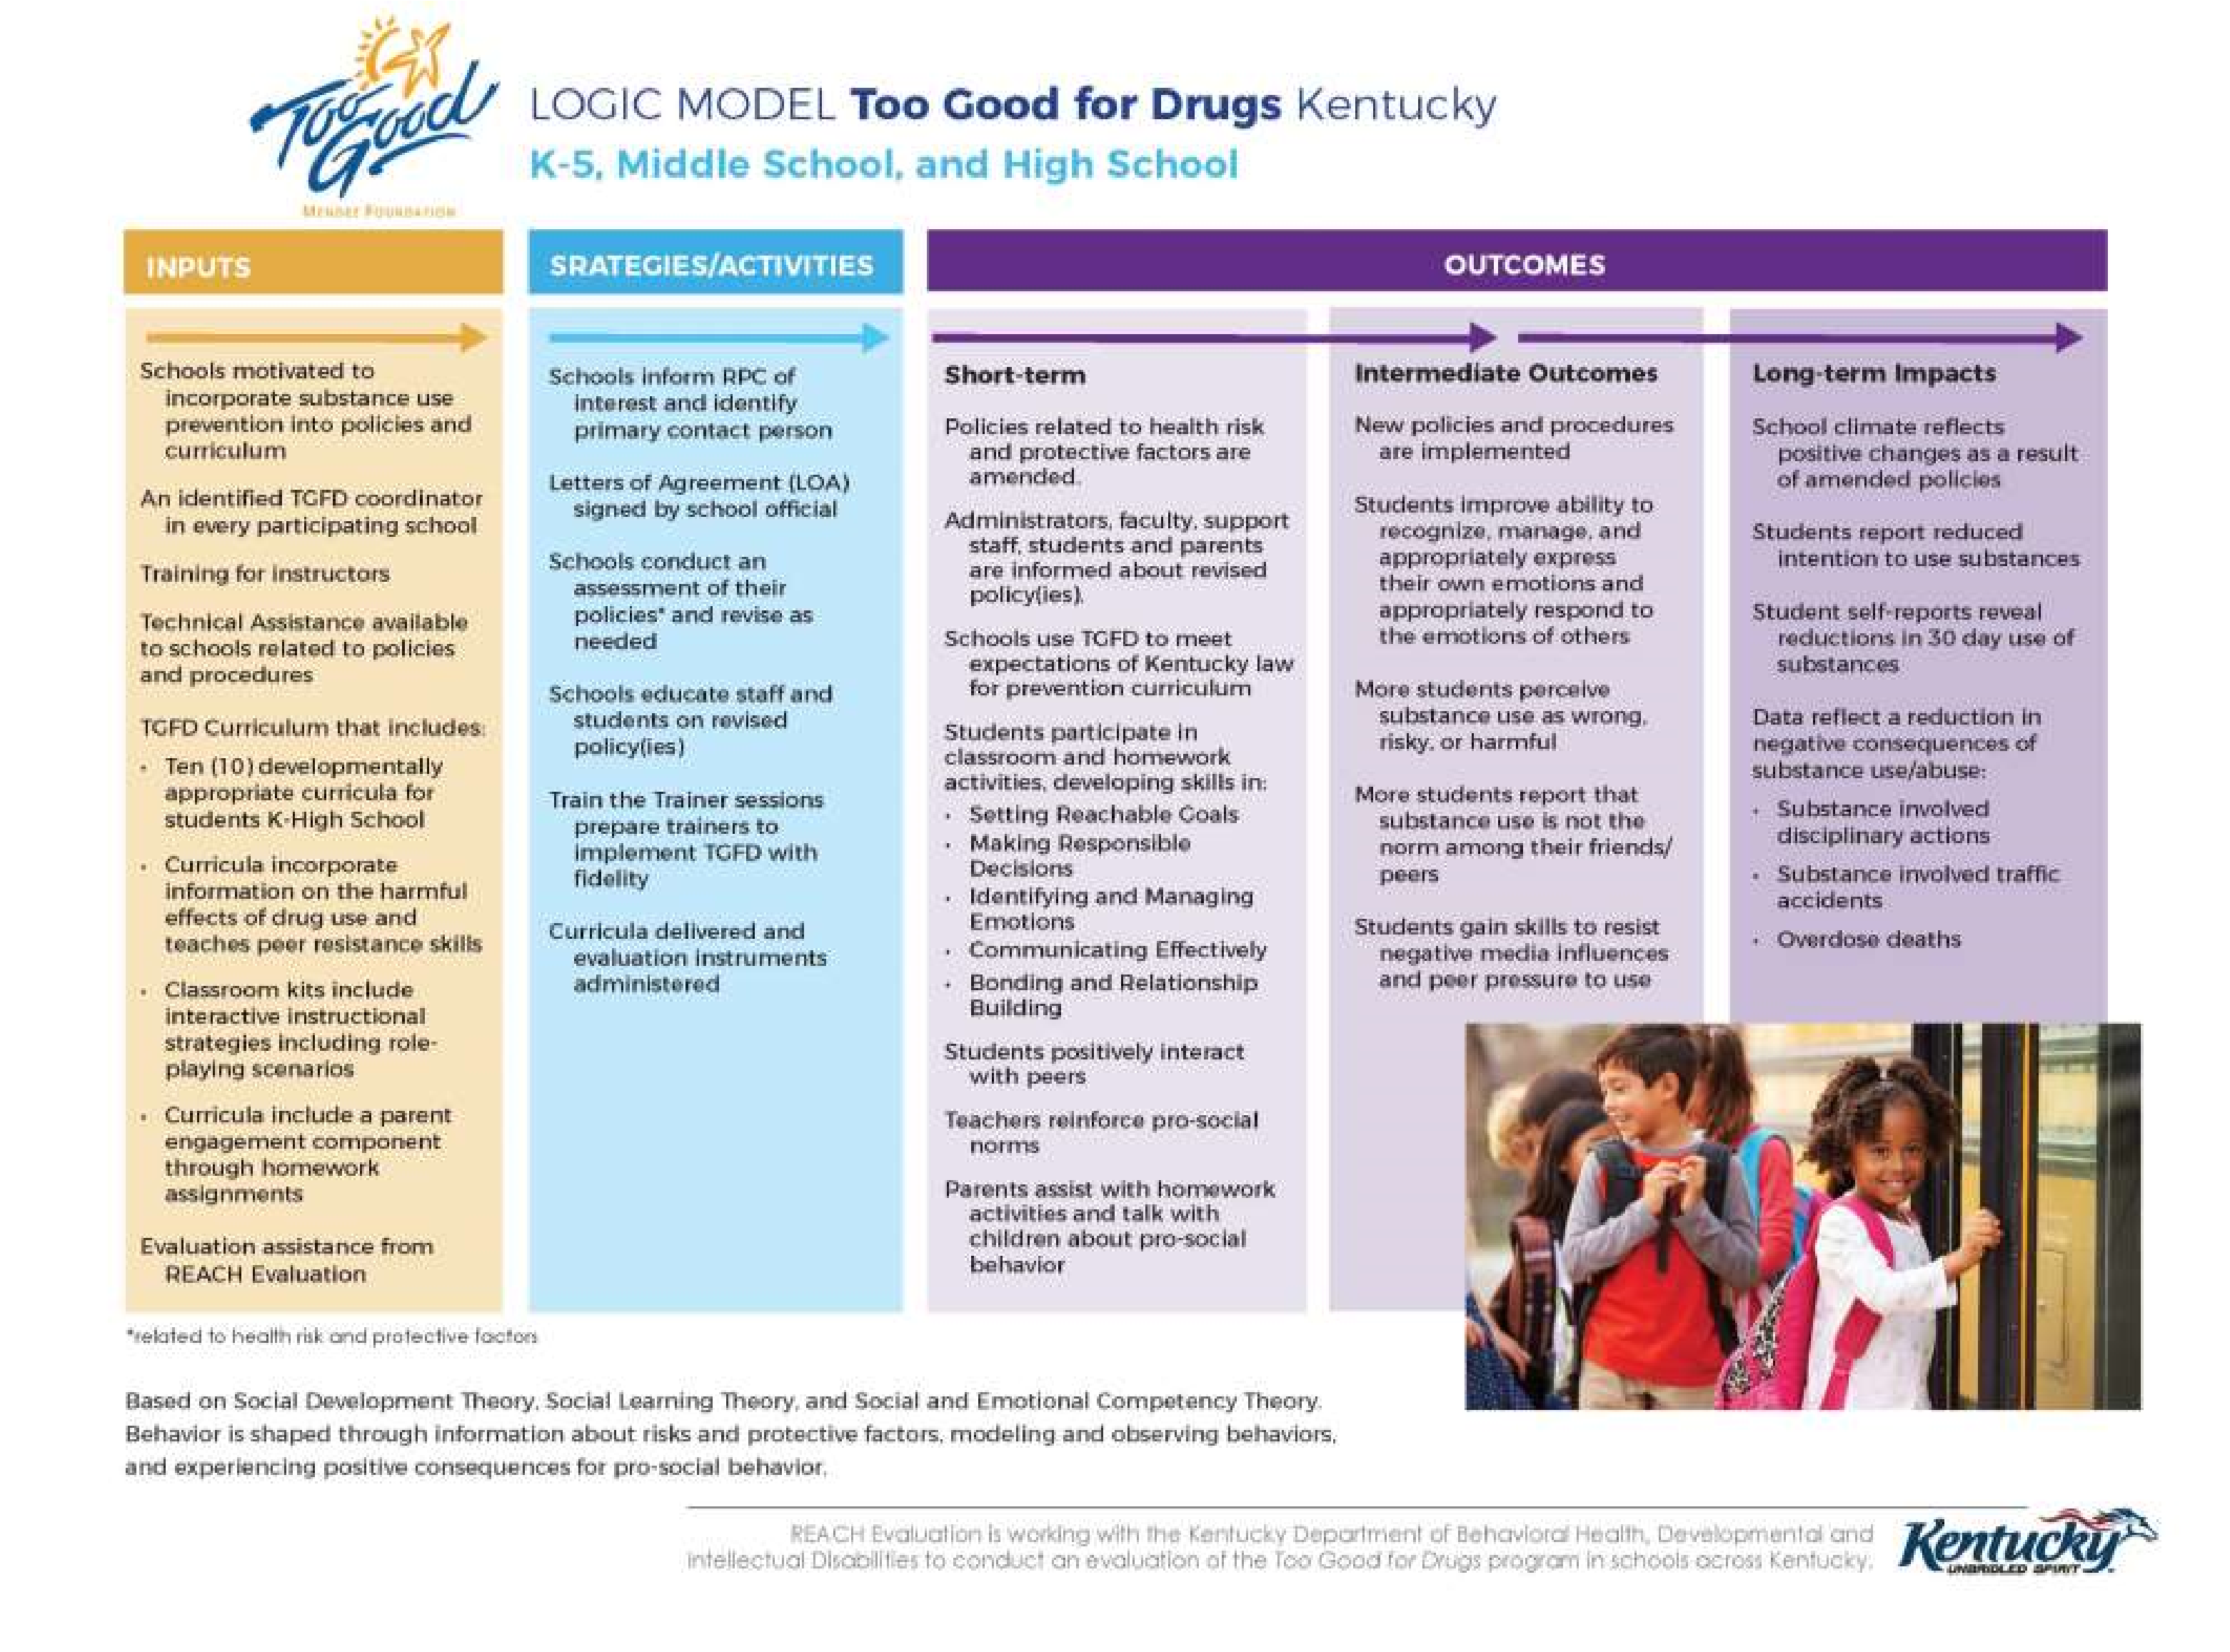

***APPENDIX D: SAMPLE PLANNING LOGIC MODEL***

**Situation/need to address:** **Strategy or Program:**

|  |  |  |  |  |  |
| --- | --- | --- | --- | --- | --- |
| RESOURCES/INPUTS | ACTIVITIES | OUTPUTS | SHORT-TERM  OUTCOMES | MEDIUM-TERM LONG-TERM IMPACTS  OUTCOMES | |
| To complete our activities we will need: | To address our local needs we will: | We expect that  once accomplished  these activities will  produce the  following evidence  of service delivery: | We expect that if  accomplished, these  activities will lead to  the following  changes in 1-3  years: | We expect that if  accomplished, these  activities will lead to  the following  changes in 4-6 years: | We expect that if  accomplished, these  activities will lead to  the following changes  in 7-10 years: |
| (List and describe necessary funding, staffing, materials, training, time, participants, etc.) | (List activities  necessary for program preparation and implementation) | (List # of teachers trained, # classes administered, # participants, etc.) | This is where we see increases in knowledge as measured by pre/post-test for example | This is where we see changes in behavior, e.g.,., increase in perception of harm, decreases in access, changes in social norms related to use | This is where we see reduction in substance use  rates |

Adapted from W.K. Kellogg Foundation’s Logic Model Development Guide, p. 25 [(http://www.wkkf.org/Pubs/Tools/Evaluation/Pub3669.pdf) a](http://www.wkkf.org/Pubs/Tools/Evaluation/Pub3669.pdf))nd University of Wisconsin Cooperative Extension [(http://extension.missouri.edu/staff/programdev/plm/LMback.pdf)](http://extension.missouri.edu/staff/programdev/plm/LMback.pdf))

***APPENDIX E: SAMPLE EVALUATION LOGIC MODEL Strategy or program:***

|  |  |  |  |  |  |
| --- | --- | --- | --- | --- | --- |
| GOALS | RISK FACTOR/  OBJECTIVE | FOCUS POPULATION | STRATEGIES | “IF-THEN” STATEMENTS | PROCESS MEASURES  (OUTPUTS) |
| What is the problem  to be changed? | What root causes or risk  factors are contributing  to the problem? | Who are the people  you are directly  targeting with the  intervention? | What strategies or  programs do you  want to implement? | Use the If-then  approach to test the  logic of your  strategy. | What should you see to  know these strategies  were implemented  well? (i.e. process measures) |
|  |  |  |  |  |  |

Adapted from Maine Office of Substance Abuse, Logic Model to test strategy fit, 2008

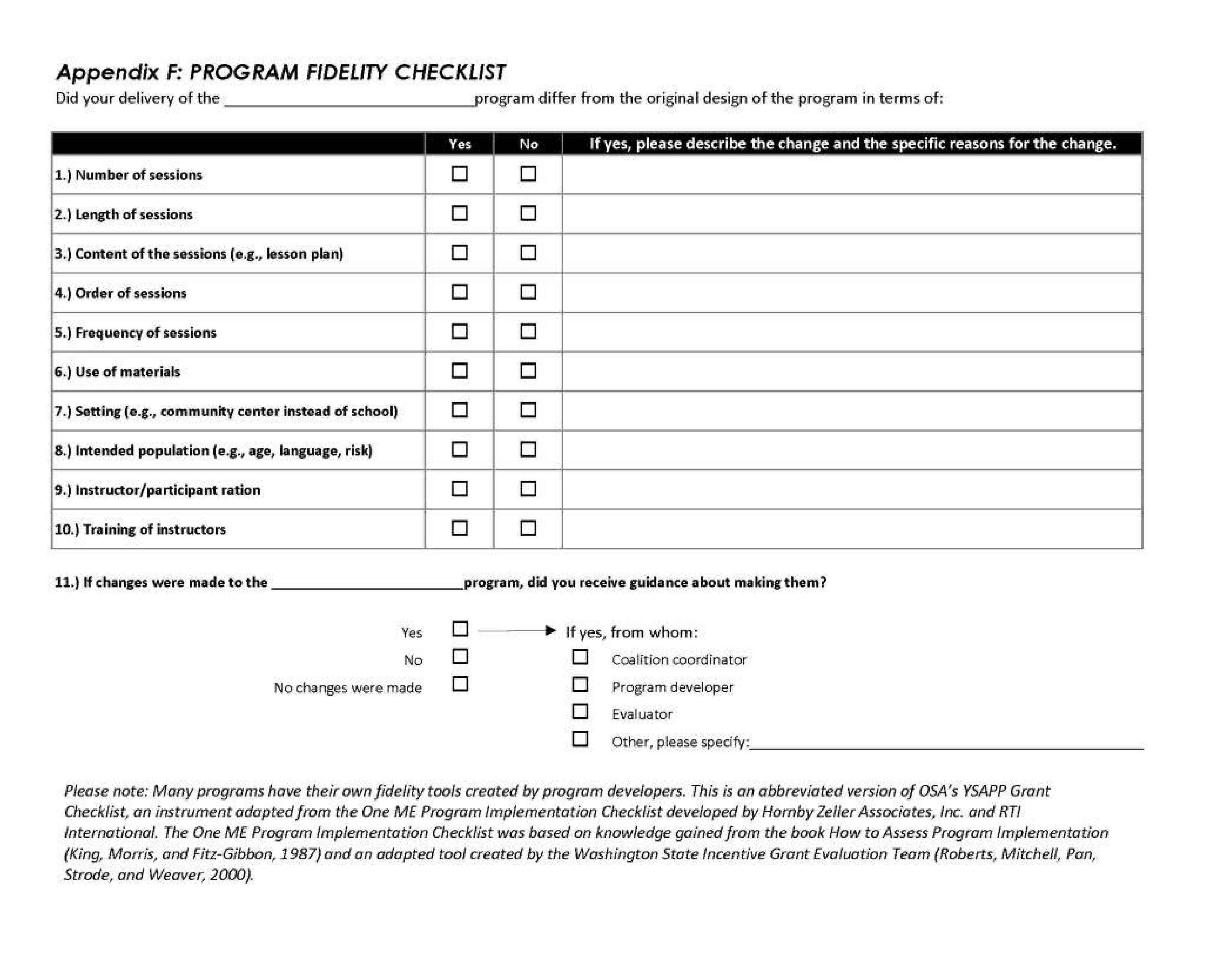

***Appendix G: Beyond Programs: Examples of Proven, Low-to-No-Cost Prevention Strategies***

In addition to the evidence-based curricula available for school prevention programs, scientific studies have identified many small but powerful prevention strategies that are inexpensive to implement and can be integrated into the day-to-day functioning of schools and classrooms. These “kernels,” as Drs. Dennis Embry and Anthony Biglan call them, are supported by rigorous experimental evidence—and often have multiple positive outcomes that can include improved academic achievement *and* decreased behavior problems (Embry & Biglan, 2008).

While many of us tend to think of adolescence as the time for substance use prevention, developmental psychologists point out that early childhood and elementary school provide important developmental windows for teaching social and behavioral skills (Biglan et al., 2004), which then translate into reduced problems down the road—including substance use/misuse. These early developmental approaches focus on changing the fundamental neurological and behavioral predictors of multi-problem behaviors such as substance use/misuse, violence, and school failure. For example, the Good Behavior Game, a first-grade classroom management intervention, not only has been found to have immediate results in reducing disruptive behavior by children, it also has been linked to important long-term outcomes—including reduced likelihood of conduct disorder by 6th grade, and reduced likelihood of substance use disorder by ages 19-21 and suicidality in adolescence (Institute of Medicine, 2009).

On the next page are examples of a few “kernels” that can be implemented at low-to-no-cost by elementary, middle, or high schools. All are examples of activities that can be made universally accessible to all students in a classroom or school. In other words, even though some of the activities might have special impact on higher-risk students in a particular classroom, they work best when they are inclusive and made available to all.

This also helps to create a supportive and reinforcing classroom or school environment.

For more information about low-cost evidence-based “kernels” for behavioral change, visit [www.paxis.org o](http://www.paxis.org o)r [www.simplegifts.com.](http://www.simplegifts.com.)

### 

|  |  |  |
| --- | --- | --- |
|  | **Description** | **Impact** |
| **Pleasant greeting with or without positive physical touch** | Friendly physical and verbal gestures, on a frequent basis | Affects social status, perceptions of safety or harm, behaviors of aggression, hostility or politeness |
| **Meaningful roles (jobs)** | Providing responsible roles to all  children in the classroom, school, or home | Increases pro-social behaviors, instructional time, and achievement, and provides positive adult and peer reinforcement & recognition |
| **Verbal praise** | Person or group receives spoken (or signed) recognition for engagement in target acts, which may be descriptive or simple acknowledgements | Increases cooperation, social competence, academic engagement/ achievement; reduces disruptive or aggressive behavior and DSM-IV symptoms |
| **Peer-to-peer written praise - “Tootle”/ compliment or praise note** | Tootles (opposite of tattles) are written compliment notes that are publicly posted or sent from school to home or home to school or from adults to children/youth. A pad or display of decorative notes are posted on a wall, read aloud, or placed in a photo type album in which behaviors receive written praise from peers. | Effective in improving positive family attention to child, social competence, school adjustment and engagement, academic achievement, work performance, and reducing problem behaviors, aggression and negative/harsh interactions; unites adults; protection against substance use and related antisocial behaviors |
| **Public posting**  **(graphing) of feedback of a targeted behavior** | Results or products of activity posted for all, e.g., scores of individuals, teams, or simple display of work products | Increases academic achievement, community participation, and injury control |
| **Peer-to-peer tutoring** | Dyads or triads take turns asking questions, giving praise or points and corrective feedback | Improves behavior, increases standardized achievement, and reduces ADHD/conduct problems and special- education placement |
| **Aerobic play or behavior** | Daily or many times per week engagement in running or similar aerobic solitary activities or games | Reduces ADHD symptoms, depression, stress hormones; may increase cognitive function; decreases PTSD |
| **Structured/Organized Play or Recess** | Structured or planned activities that emphasize turn taking, helpfulness, rule following, and emotion control with or without “soft competition” | Dramatically improves cooperative behavior, social competence; affects BMI; reduces social rejection; decreases bullying and aggression; improves social norms and academic learning during the day; and reduces ADHD and other disturbances |

|  |  |  |
| --- | --- | --- |
| **Kernel Description Impact** | | |
| **Good Behavior Game** | A team-based, response-cost protocol for groups of children that rewards inhibition of inattentive, disruptive, and aggressive/bullying behavior. | Reduces short-term and long-term behavior problems as well as DSM-IV ADHD and conduct problems, special- education placement, and substance use initiation |
| **Beat the timer/ buzzer** | Use small timers to reduce allocated time for task, with access to reward or recognition if task successfully completed before time interval | Powerful effects for reducing negative behaviors, child aggression, physical abuse, ADHD; and improving parent child interactions, work completion, and  academic accuracy |
| **Choral responding** | Person(s) chant (or sign) answer to an oral or visual prompt in unison; praise or correction follows | When compared to hand raising, improved academic achievement and retention; reduced disruption and behavior problems |
| **Stop clock** | Clock is triggered when children misbehave; lower times on the clock result in access to rewards | Increases academic engagement; reduces disruptions |
| **Stop lights/Red flag** | Traffic light/flag signals when behavior is appropriate/desirable or  inappropriate/undesirable in real time, and connected to some kind of occasional reinforcement | Decreases noise, off task behavior; reduces explosive anger and aggression among children exposed to drugs, neglect, or abuse |
| **Response cost** | Removal of token, money, or privilege for misbehavior without emotional displays. | Decreases inattention and disruption; works as well as stimulant medication for children with ADHD; may, if used as a part of teams in first grade, decrease substance misuse over lifetime |
| **Nonverbal transition cues** | Nonverbal (visual, kinesthetic, and auditory) cues for transitions (stopping one task & starting another) that signal shifting attention or task in patterned way, coupled with praise or occasional rewards | Reduces problem behaviors, dawdling; and increases time on task or engaged learning |
| **Team competition** | Groups compete on some task, performance, or game | Improves academic engagement and achievement; reduces disruptive behavior, smoking; increases safety; changes brain chemistry favoring attention and endurance |

**Appendix H: State Approaches**

## Youth Initiatives

40 Developmental Assets

All Stars

Coaches Initiative / Life of an Athlete Program

Guiding Good Choices

Life Skills Training

Lifelines - A Suicide Prevention Program

Not on Tobacco (N-O-T)

Olweus Bullying Prevention Program

Prime for Life

Project ALERT

Project Northland

Project Towards No Drug Abuse (TND)

Smart Mouth

Sources of Strength

Teens Against Tobacco Use (TATU)

The Leader in Me

Too Good for Drugs

Too Good for Violence

Truth and Consequences: The Choice is Yours

## Staff Development

Applied Suicide Intervention Skills Training (ASIST)

Mental Health First Aid for Youth (for adults who work with youth)

Naloxone/Narcan Training

Opioid Prevention Toolkit

Question, Persuade Refer (QPR)

Screening, Brief Intervention, and Referral to Treatment (SBIRT) training

S ScScrr

**Funding Opportunities**

Youth Empowerment Grants

**Appendix I: Regional Prevention Centers**

**Four Rivers RPC**

Cynthia Turner, Director

[cturner@4rbh.org](mailto:cturner@4rbh.org)

425 Broadway, Suite 202, Paducah, KY 42001

(270) 442-8039 Ext. 1716; Fax (270) 442-5729

**Serves**: Ballard, Calloway, Carlisle, Graves, Hickman, Fulton, Livingston, Marshall, McCracken

**Pennyroyal RPC**

Chris Sparks, Director

[csparks@pennyroyalcenter.org](mailto:csparks@pennyroyalcenter.org)

P.O. Box 614, Hopkinsville KY 42241

607 Hammond Plaza, Hopkinsville, KY 42240

(270) 886-0486

**Serves**: Caldwell, Christian, Crittenden,

Hopkins, Lyon, Muhlenberg, Todd, Trigg

**RiverValley RPC**

Brooke Arnold, Director

[arnold-brooke@rvbh.com](mailto:arnold-brooke@rvbh.com)

P.O. Box 1637, Owensboro, KY 42302

1100 Walnut St., Owensboro, KY 42301

(270) 689-6564; Fax (270) 689-6677

**Serves**: Daviess, Hancock, Henderson, McLean,

Ohio, Union, Webster

**LifeSkills RPC**

Amy Hutchinson, Director

[ahutchinso@lifeskills.com](mailto:ahutchinso@lifeskills.com)

P.O. Box 6499, Bowling Green, KY 42103

380 Suwannee Trail, Bowling Green, KY 42102

(270) 901-5000 Ext. 1277

**Serves**: Allen, Barren, Butler, Edmonson, Hart, Logan, Metcalfe, Monroe, Simpson, Warren

**Communicare RPC**

Tara Smith, Director

[tcsmith@communicare.org](mailto:tcsmith@communicare.org)

1311 N. Dixie Avenue, Bldg. A

Elizabethtown, KY 42701

(859) 336-4360

**Serves:** Breckinridge, Grayson, Hardin, LaRue, Marion, Meade, Nelson, Washington

**Seven Counties RPC 06**

Patty Gregory, Director

[pgregory@sevencounties.org](mailto:pgregory@sevencounties.org)

10401 Linn Station Rd., Suite 100

Louisville, KY 40223

(502) 593-4215

**Serves**: Bullitt, Henry, Jefferson, Oldham,

Shelby, Spencer, Trimble

**NorthKey RPC 07**

Angelena Boone, Director

[Angelena.Boone@northkey.org](mailto:Angelena.Boone@northkey.org)

502 Farrell Drive, Covington, KY 41011

(859) 578-3200; Ext. 2790; Fax (859) 491-0183

**Serves**: Boone, Campbell, Carroll, Gallatin, Grant, Kenton, Owen,

Pendleton

**Comprehend RPC**

Tara Anderson

[tanderson@comprehendinc.org](mailto:tanderson@comprehendinc.org)

731 Kenton Station Road, Maysville, KY 41056

(606) 759-7799; Fax (606) 759-7609

**Serves**: Bracken, Fleming, Lewis, Mason, Robertson

**Pathways RPC**

Amy Jeffers, Director

[Amy.Jeffers@pathways-ky.org](mailto:Amy.Jeffers@pathways-ky.org)

P.O. Box 790, Ashland, KY 41105

1200 Bath Ave. Ashland, KY 41101

(606) 329-8588 x4099

**Serves**: Bath, Boyd, Carter, Elliott, Greenup, Lawrence,

Menifee, Montgomery, Morgan, Rowan

**Mountain RPC**

MaShawna Jacobs, Director

[Mashawna.Jacobs@mtcomp.org](mailto:Mashawna.Jacobs@mtcomp.org)

173 North Lake Drive, Prestonsburg, KY 41653

(606) 889-0328; Fax 606-889-6427

**Serves**: Floyd, Johnson, Magoffin, Martin and Pike

**Kentucky River RPC**

Jamie Mullins-Smith, Director

[jamie.smith@krccnet.com](mailto:jamie.smith@krccnet.com)

3834 Hwy 15 S., Jackson, KY 41339

(606) 666-7591 Ext. 7100; Fax (606) 666-4151

**Serves**: Breathitt, Knott, Lee, Leslie, Letcher, Owsley,

Perry, Wolfe

**Cumberland River RPC**

Jill Owens, Director

[jill.owens@crccc.org](mailto:jill.owens@crccc.org)

223 S. Cherry St., Pineville, KY 40977

(606) 337-2070

**Serves**: Bell, Clay, Harlan, Jackson, Knox, Laurel,

Rockcastle, Whitley

**Adanta RPC**

Sherri Estes, Director

[sestes1@adanta.org](mailto:sestes1@adanta.org)

130 Southern School Road, Somerset, KY 42501

(606) 679-9425 Ext. 2272; Fax 606-679-3095

**Serves**: Adair, Casey, Clinton, Cumberland,

Green, McCreary, Pulaski, Russell, Taylor, Wayne

**New Vista RPC 15**

Shawn Freeman, Director  
[shawn.freeman@newvista.org](mailto:shawn.freeman@newvista.org)

1351 Newtown Pike, Building 3

Lexington, KY 40511

(859) 225-3296

**Serves**: Anderson, Bourbon, Boyle, Clark, Estill,

Fayette, Franklin, Garrard, Harrison, Jessamine,

Lincoln, Madison, Mercer, Nicholas, Powell, Scott,

Woodford

**Kentucky’s Regional Prevention Centers**

(part of Kentucky’s Community Mental Health Center system)

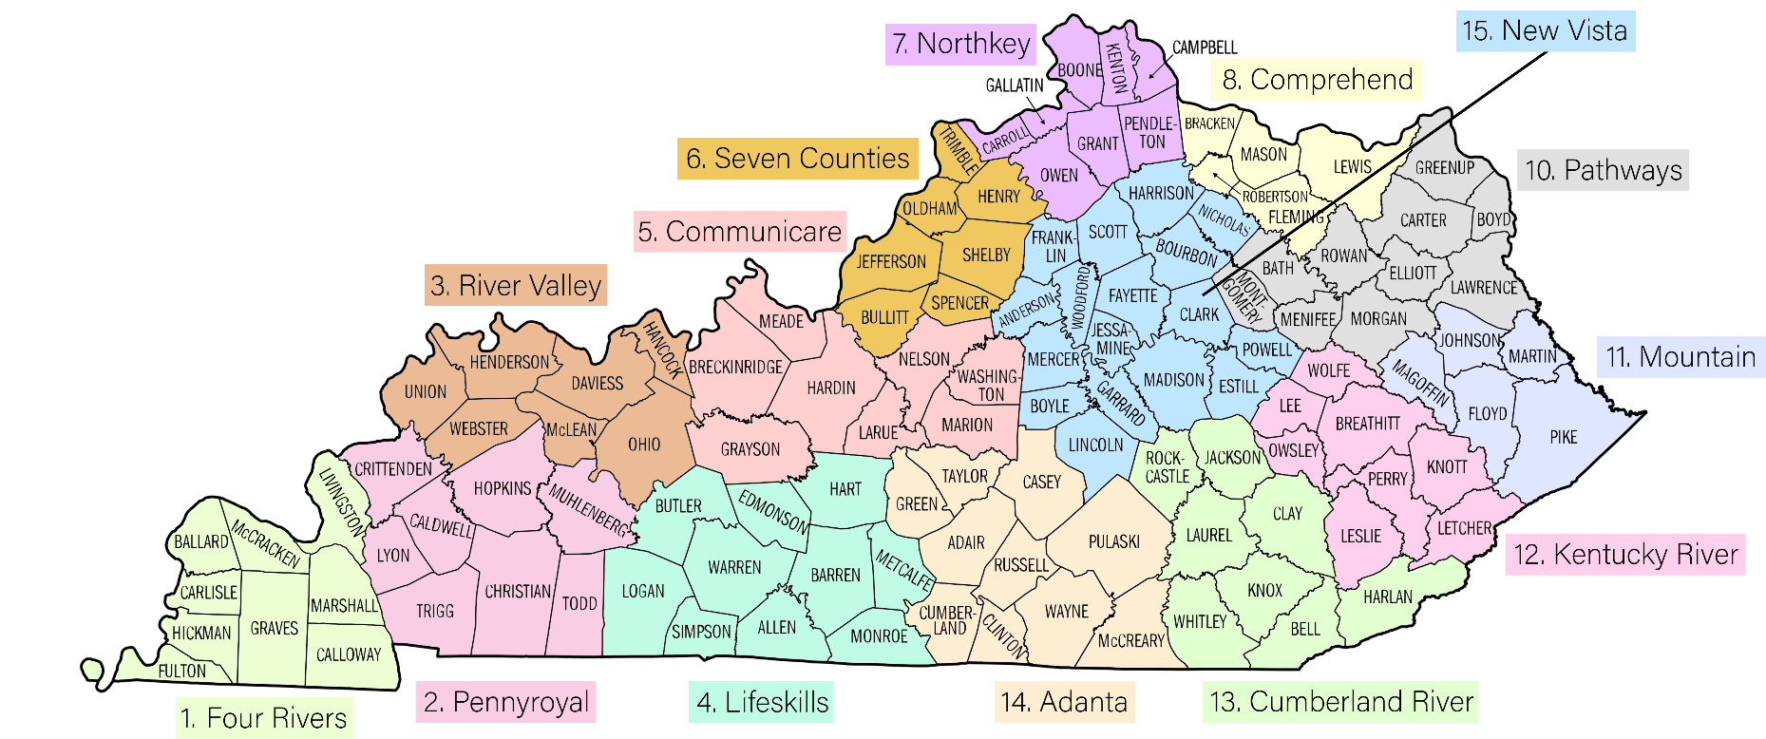

**References Cited**

Biglan, A., Brennan, P. A., Foster, S. L., Holder, H. D., Derzon, J. H., Embry, D. D., et al. (2004).

Helping Adolescents at Risk: Prevention of Multiple Problem Behaviors. New York: Guilford Press.

Committee on Prevention of Mental Disorders and Substance Abuse among Children, Youth, and

Young Adults: Research Advances and Promising Interventions. Board on Children, Youth, and Families, Division of Behavioral and Social Sciences and Education. Washington, DC: The National Academies Press.

Embry, D. D., & Biglan, A. (2008). Evidence-Based Kernels: Fundamental Units of Behavioral Influence.

Clinical Child & Family Psychology Review, 11(3), 75-113.

Institute of Medicine. (2004). Reducing Underage Drinking: A Collective Responsibility. Retrieved from <http://www.nap.edu/openbook.php?record_>id=10729&page=R1.

National Research Council & Institute of Medicine. (2009). Preventing mental, emotional, and behavioral disorders among young people: Progress and possibilities. ME O'Connell, T Boat, & K E Warner (Eds).